The members of our team are:

Eric Chen: initialized the starting and ending screens

Hung Huynh: coded edge detection functions and shooting algorithm

Masuma Mansur: made function for falling rocks

Matthew Persad: wrote loops for player movements

Christopher Verch: made function for shooting bullets

For the game itself, the user plays as red square, which has to avoid “rock” objects, the black squares. These rocks are created in random sizes at the top of the screen, move down the screen, and disappear at the bottom of the screen. Every five seconds, the speed, size, and spawn rate of of the rocks increase and the game gets more difficult as time goes on. While the rocks fall, the player object uses the arrow keys to dodge the rocks.  We were also able to implement a shooting algorithm, where the player can continuously fire “bullet” objects. When these bullet collides with a rock, each bullet decreases the size of the rock by four pixels until the rock is less than 15 by 15 - where it will then be deleted.

For the remaining two weeks, we plan to create randomly generated power-ups that will assist the user as the difficulty increases.

So far, we have successfully created a game window and a surface where a tentative title of the game and instructions can be displayed.  Both can and will be improved as the project develops and we have a better understanding of what we want the game to be.  The display functions are a bit clunky because every line of text needs a function call; we will later streamline the code so the program will be more readable.

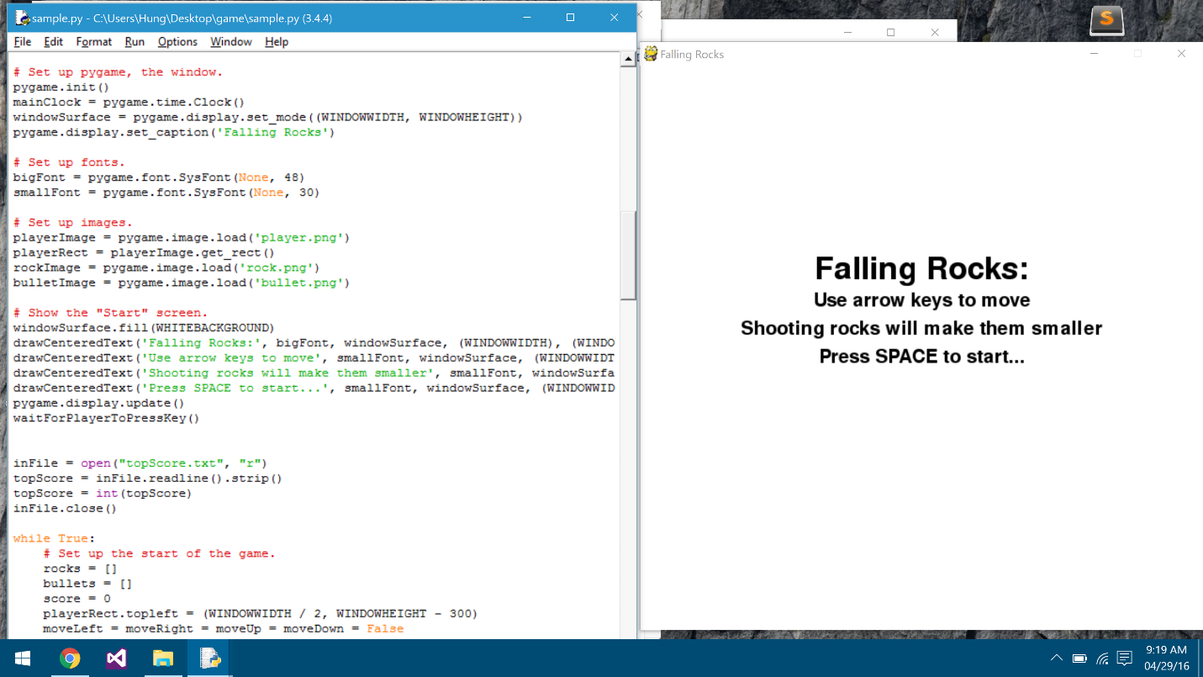

When the game starts up, the player can use the arrow keys to move the red square around the screen to dodge and shoot the falling squares.  The score on the upper left corner increments by 1 pointer every time the window refreshes and since the frame rate is 40 FPS, there will be 40 points per second of gameplay.

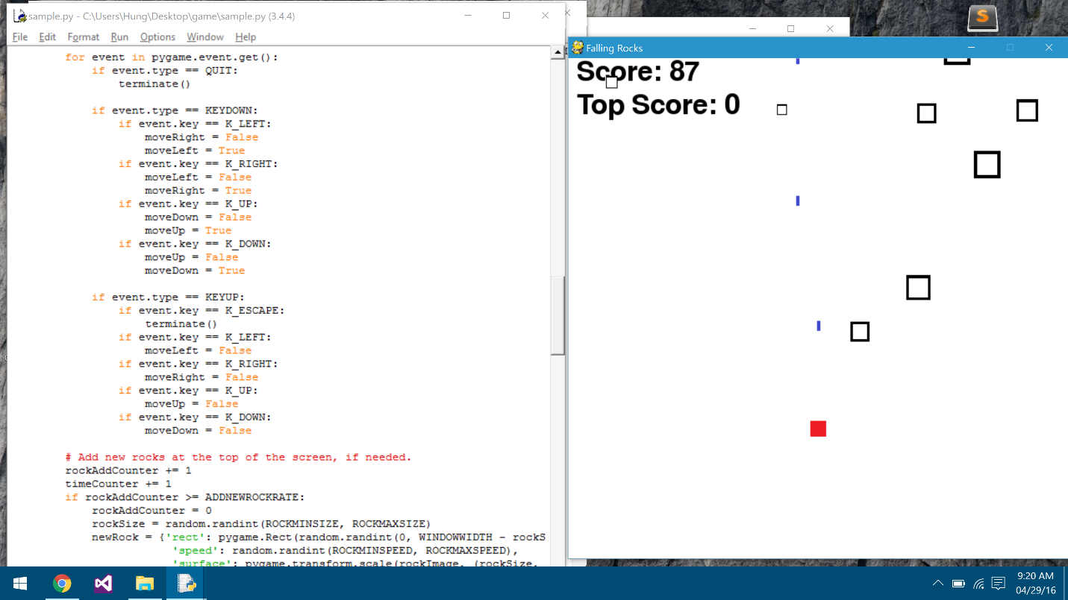

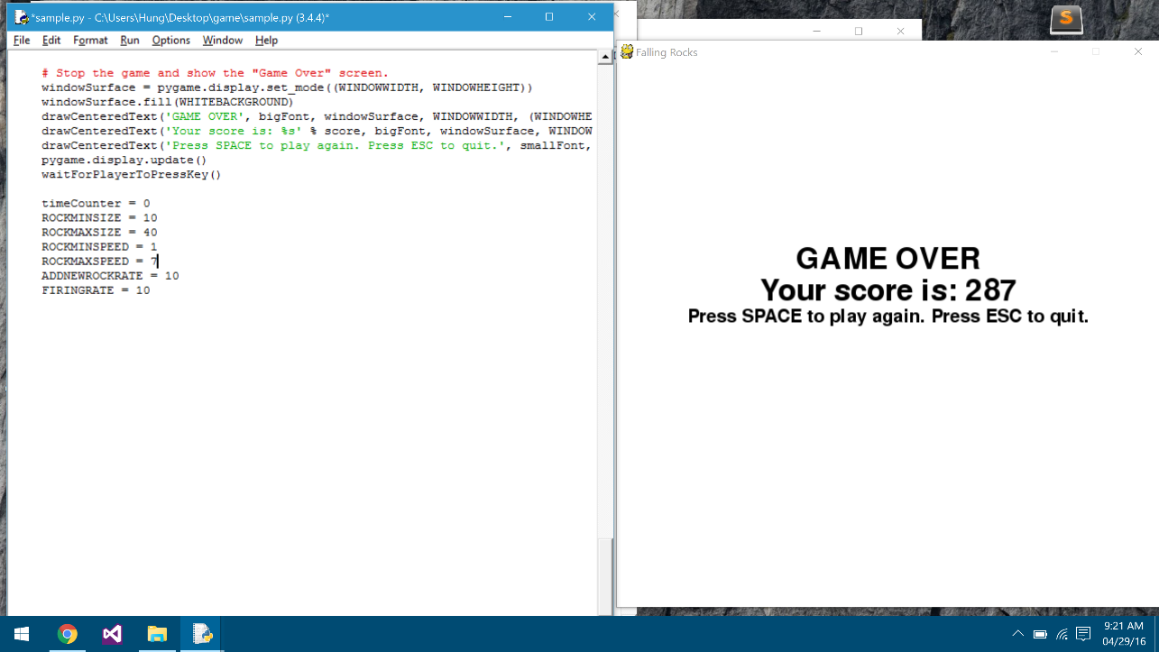When the player collides with a rock, the game ends and displays the total score of that playthrough. If the current score is higher than the high score, then it will become the high score.  Below the score, two options are provided: press the spacebar to play again (the game restarts), or press escape to quit (the program ends).